Grace Abbott Elementary 2015 Spring Box Top Raffle
Friday, March 13 to Friday, April 10th
Student's Name __________________ Teacher's Name ___________________ Grade _____

- This is your Raffle Ticket so be sure to complete Student's Name, Teacher's Name and Grade
- Make sure the Box Top has a visible and valid expiration date
- Glue or tape 1 box top to each Gator (no staples!)
- Bonus Box Tops should be taped or glued to the back of the sheet and the appropriate number of Gators crossed off
- Additional sheets can be found at http://graceabbottpto.com/spring-box-tops-raffle

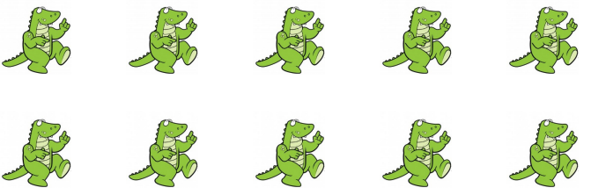

Cut here

